Arthritis treatment moving in a new direction
The Richmond Sentinel·Wednesday, March 29, 2017
- Grandma was right; you will rust out before you wear out
- Arthritis is not a part of normal aging
- Arthritis can be delayed, slowed, and sometimes stopped
By Lorraine Graves Lgraves@richmondsentinel.ca @LGSentinel
When the Canadian Arthritis Society hived off its research arm into a separate entity which became Arthritis Research Canada (ARC) it gained a powerful new ally in the Milan and Maureen Ilich Foundation. The foundation donated two floors in their Progressive Construction building on No. 3 Road near Lansdowne Centre.
More than just the floor space, the foundation also donated the cost of operating those floors. That means all money donated to ARC goes straight to our research and not to overhead, says spokesperson Kevin Allen.
Described by scientific director Dr. John Esdaile as one of ARC’s stars, Dr. Linda Li started her career as a physiotherapist before going onto a PhD and a faculty position in UBC’s department of physiotherapy.
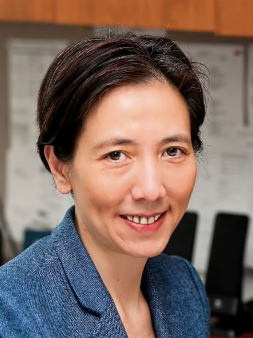
Dr. Linda Li, principal co-researcher
“I fell in love with doing research in arthritis and the people I work with in the field,” says Li. Medical discoveries only become valuable when put to use. That is why Li aims to make sure that patients and doctors learn about new scientific knowledge, like the proven value of exercise in arthritis.
“That’s knowledge translation,” she says.
Li’s latest research project looks at ways to get creaky joints moving to keep the cartilage, the cushion in our joints, healthy.
She says cartilage is like a sponge so, just as you repeatedly squeeze a sponge in clear water to clean it, the only way to flush nutrients through the cartilage is to move the joint. The pressure and release when you move a joint flushes the cartilage with the natural fluids it needs to be healthy.
“Our study is to look at what it takes to develop the skills and habit to be fit,” she said.
Li designed this project because, “Inactivity is the biggest risk to today’s society for all chronic diseases including arthritis. In fact, not being active puts you at greater risk for developing osteoarthritis, the most common kind of arthritis.”
Li’s new study has three components. The first is educational. Patients learn why they need to move to keep their arthritis in check.
“We are trying to instill the concept that moving is good for your joints. We talk about, ‘Move more. Sit less.’ But we are not prescribing a specific activity or exercise.”
In the second part of the project, the participants meet their physiotherapist who will encourage them throughout the project, helping them set realistic goals, how to manage pain and how to know the difference between exercise that hurts their joint and exercise that helps them heal. They will then meet by phone every two weeks for a couple of months.
The third component of the study involves an electronic activity tracking device known as a Fitbit for each participant so they and their physiotherapist can tell if their gradual fitness plan is working. If a participant doesn’t reach their goals, they can work with their physiotherapist by phone to see what got in the way and to set more realistic goals.
“If the goals weren’t realistic, we can dial them back a bit,” says Li. If the participant hits all their goals, activity can gradually increase and with it, joint health.
With the use-it-or-lose-it philosophy now supported by good science, Li says, “We want to help people with arthritis, who are not physically active, become more active.”
Li loves her research: “I like the complexity of it. The field is full of really good people, colleagues, and mentors so once you get into it, you don’t want to leave.”
Caption for top photo. Dr. Antonio Avina, rheumatologist, giving patient a preliminary mobility exam. Photos by Chung Chow

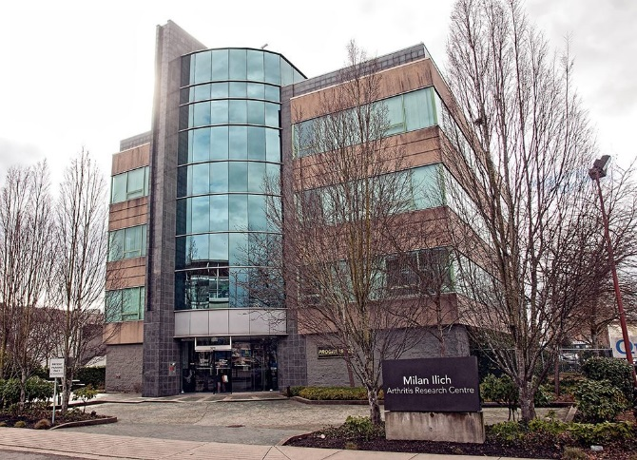
ARC headquarters on No. 3 Road

